Two-level CSPro Applications

We recommend that two-level CSPro applications be avoided when possible. However, in some cases that is not possible. Here is an example of a “building” questionnaire: Building information followed by that for each household and its members in the building. It is important that the members be associated with the household as well as the building.

Building

HH # 1
HH # 2

Person #1
Person #3
Person #2
Person #1

In the above example we would want to process the records as follows:

Building information
Household #1 information
Person #1 information
Person #2 information
Person #3 information
Household #2 information
Person #1 information

In doing cross tabulations we want to be able to cross person characteristics with household characteristics. To do this the case cannot be treated as two house records and four person records. If crossing Building characteristics with Household or Person characteristics then this is appropriate.

There is no other reasonable way to treat this case except as a two-level application. We will define three record types: Building record, Household record, and Person record. Each case will have one record for building information followed by nodes for each household. This node consists of the Household record followed by a Person record for each member of the household.

Topics
- Information on each record
- Data dictionary items
- Data entry forms
- Entering data
- Data file

Information on each record

Here is the information that we are collecting:

Level Building [Building ID (HH ID = blank)] ---- a case
Record Building information
Type of roof
Type of water source
Number of HUs
Level Household [multiple] [Building ID + HH ID] ---- a node in a case
Record Household information
Telephone
Type of heat
Personal computer
Record Person information
Line number
Sex
Age
Marital status

Data Dictionary items

Here is the listing of the data dictionary:

Records in levels

-----------------------------------------------------------------------
Level Label Level Name
Record Label Record Name
-----------------------------------------------------------------------
two-level questionnaire TWO_LEVEL_QUEST
Building record BUILD_REC
Household HOUSEHOLD
Housing record HOUSE_REC
Person record POP_REC

Items on records

Level: two-level questionnaire Record: Building record
------------------------------------------------------------------------------

Item Label Item Name Start
-------------------------------------------------------------------------------
(record type) 1
province (id) PROV 2
district (id) DIST 4
village (id) VILLAGE 6
enumeration area (id) EA 8
building number (id) BUILD 11
House number (id) HOUSE_NUMBER 14
Type of roof ROOF 17
Type of water source WATER 18
Number of HUs NUMBER_OF_HUS 19

Level: Household Record: Housing record
-------------------------------------------------------------------------------

Item Label Item Name Start
-------------------------------------------------------------------------------
(record type) 1
province (id) PROV 2
district (id) DIST 4
village (id) VILLAGE 6
enumeration area (id) EA 8
building number (id) BUILD 11
House number (id) HOUSE_NUMBER 14
Telephone TELEPHONE 17
Type of heat HEAT 18
Personal computer PC 19

Level: Household Record: Person record
-------------------------------------------------------------------------------

Item Label Item Name Start
-------------------------------------------------------------------------------
(record type) 1
province (id) PROV 2
district (id) DIST 4
village (id) VILLAGE 6
enumeration area (id) EA 8
building number (id) BUILD 11
House number (id) HOUSE_NUMBER 14
Line number LINE 17
Sex SEX 19
Age AGE 20
Marital status M_STATUS 23

Note: values are not listed for items to condense the listing.
Data Entry form

Sample Case Level Form [Building record]
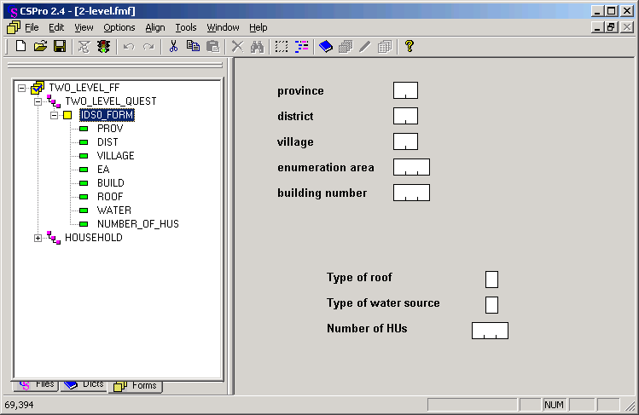

Sample Node Level Form [Household and Person records]

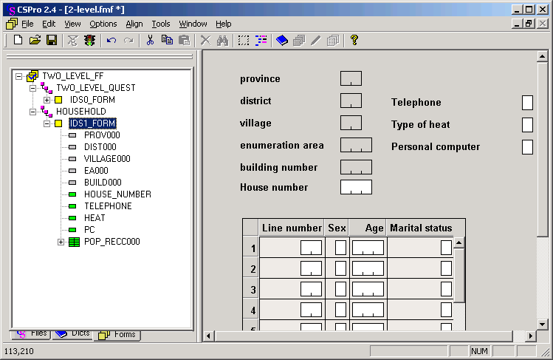

Notes:
There is NO ‘House number’ ID on the ‘case form’.
The ONLY ID on the ‘node form’ is the ‘House number’

Entering data

Data entry of the above example would be:

- Enter data on ‘Case form’ [building ID + information] – ‘Accept’ writes to disk
- Enter HH #1 data on ‘Node form’ [Household ID + information] – F12 to accept ‘node’ when completed; write to disk.
- Enter HH #2 data on ‘Node form’ [Household ID + information] – F12 to accept ‘node’ when completed; write to disk.
- Ctrl+F12 to complete case [ or you can Partial Save if allowed].

Data File

A test data file of two cases:

building ID <HH><- record data ->
ID
1010101001001 11001 <- building
2010101001001001111 <- household #1
30101010010010011121111<- person #1
31111010010010012111111<- person #2
31111010010010013220222<- person #3
2010101001001002222 <- household #2
30101010010010021222122<- person #1
1111101001002 22002 <- next building
2111101001002001111
31111010010020012220222
2111101001002002222

